Assessment Schedule – 2015
Mathematics and Statistics: Apply geometric reasoning in solving problems (91031)
Evidence Statement

One | Expected coverage | Achievement | Merit | Excellence
(a)(i) | ACL = DCL (symmetry)  (ACK = 90 – 24 (angles on a line))  BCF = 90 – 24 = 66° | 1 angle statement with reason.  OR correct angle calculated. | Answer correct with reason.
(ii) | CDG = CGD (isosceles triangle)  2CGD = 180 – 66 (sum of angles of triangles)  CGD = 114/2  = 57° | 1 angle statement with reason.  OR CGD calculated. | Answer correct  with reason.
(iii) | CL = 1.2 m  KL = 1.2 tan 24°  = 0.53 m | Correct expression to lead to solution of 0.53 m.
(iv) | 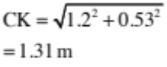 | Correct solution.
(v) | 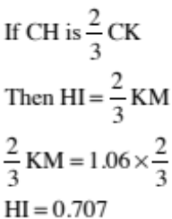  OR  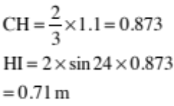 | Recognition of relationship between HI and KM.  OR  Calculation of ½ of HI. | Recognition of relationship between HI and KM with reason.  OR  Correct solution found with incomplete statements | Correct solution with correct Geometric Reasoning  OR  Correct solution with correct trig statements
(b) | Area of MNP = 0.5NP × h  = 0.5 NP . MT  Area of MQS = 0.5 QS × h  = 0.5 QS × MR  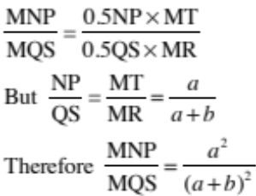 | Equation of area of triangle.  OR  Correct ratio for lengths of sides. | Establishment of comparison of areas of triangles. | Proof correct.  OR gives correct scale factor and squares it.

NØ | N1 | N2 | A3 | A4 | M5 | M6 | E7 | E8
No response or no relevant evidence | One point made incompletely | 1u | 2u | 3u | 2r | 3r | t | 2t

Two | Expected coverage | Achievement | Merit | Excellence
(a)(i) | 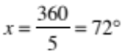  Sum of exterior angles of any polygon (or pentagon)  = 360°.  Regular shape – the angles are equal. | Correct answer and reason.
(ii) | Angle at a point  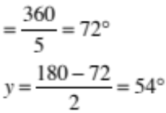  (base angles isosceles triangle)  The distance from centre to vertex is always the same in a regular polygon (pentagon).  OR  Interior angles of a regular polygon / pentagon = 108°.  OD would bisect the angle in a regular pentagon  y = 54° | y value correct. | y value correct with justification.
(b)(i) | 50°  The tangent meets the radius at 90°. | Correct angle and reason.
(ii) | AOB = 100° angle at the circumference = half the angle at the centre OAB = 40°  OR  BAC = 90° (angle in a semi circle)  OAB = 40° (angle sum of triangle) | 1 angle statement with reason. | Answer correct with reason.
(iii) | LNM = (angle at circumference)  NLM = 90° (angle in a semi-circle)  NM = 2 × radius  Therefore can use trigonometry to express NL in terms of x and a  cos = 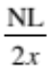  NL = 2x cos  OR  NML = 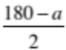  (base angles isosceles triangle)  NL = 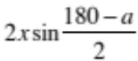 | One step in calculation with reason. | Progress towards solution or correct solution with incomplete reasoning. | Correct solution with reasons.
(c) | OSR = OYR = 90°  (angles between tangents and radii)  OX = OS = OY (radii of circle)  OXS = OSX (isosceles triangle)  RSZ = 90 – x (angles on a line)  SZR = 90 – x (angle sum of triangle XYZ)  Therefore RSZ is Isosceles  RS = RZ  OR  SRZ = 2x (angle sum of triangle)  YRS = 180 – 2x  YOS = 2x  Therefore OSRY is a kite.  YR = SR = RZ  SR bisects YZ | At least 2 steps towards answer completed – may be one relationship and one reason. | At least 4 steps in relationship found. | Relationship proved.

NØ | N1 | N2 | A3 | A4 | M5 | M6 | E7 | E8
No response or no relevant evidence | One point made incompletely | 1u | 2u | 3u | 2r | 3r | t | 2t

Three | Evidence | Achieved | Merit | Excellence
(a)(i) | 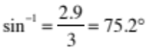  Yes the ladder is long enough. | Calculation correct. | Conclusion made.
(ii) | Distance from base  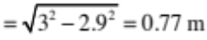 | Distance Found
(iii) | 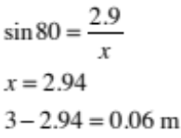  above the tank | Setting up of equation. | Solving for x and calculating difference.
(b)(i) | BCD = 108° (corresponding angles) | Correct angle and reason.
(ii) | If TUR = x  UTS = 180° – x (co-interior angles)  And if  URS = y  RST = 180° –y (co-interior angles)  But  x + 180 – y = 180 (opposite angles of a cyclic quadrilateral)  Therefore x = y  Therefore the trapezium is symmetrical.  Therefore RS = TU  And RSTU is an isosceles trapezium, which is true for all trapeziums inscribed in a circle. | Two correct statements or one statement with a reason other than that used in part (i). | Recognition with reason the trapezium is isosceles. | Generalisation.
(c) | Calculating the northern components of the first two flight paths:  40cos50 + 45 = 25.71 + 45  = 70.71  Northerly component for third path of flight  = 135 – 70.71  = 64.29 km  Westerly component  = 40 sin 50  = 30.64  Length of third flight path  = 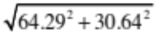  = 71.2 km  Angle = tan^{–1}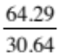  = 64.5°  Therefore bearing = 90 – 64.5  OR 026 or 025  71.2 km on a bearing of 025 or 026 | Calculation of the northerly or westerly component of the first section of the flight. | Correct calculation of the bearing or the distance for the third section of the flight. | Distance and bearing calculated for the third section of the flight.

NØ | N1 | N2 | A3 | A4 | M5 | M6 | E7 | E8
No response or no relevant evidence | One point made incompletely | 1u | 2u | 3u | 2r | 3r | 1t | 2t

Cut Scores
Not Achieved | Achievement | Achievement with Merit | Achievement with Excellence
0 – 7 | 8 – 13 | 14 – 18 | 19 – 24

